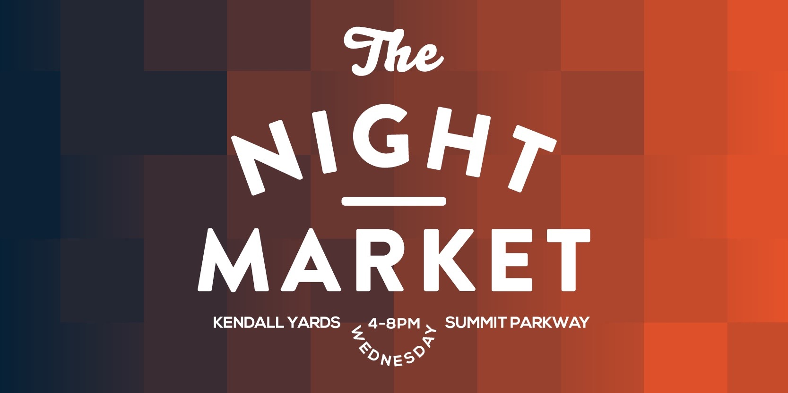

2021 Season Vendor Welcome Letter

Welcome to all of our vendors for the 2021 market season!

Thanks to all of our vendors that made last year so successful even through the hardship of the pandemic. We are honored to have you all on board for the 2021 Kendall Yards Market.

We welcome many of our vendors back from last year and a group new vendors that will increase the breadth and quality of farm product and artisan foods available in the market. A full listing of our 2021 vendor list will be on the website soon. The opening day for the market will be Wednesday, May 22nd.

Our annual pre-season vendor meeting, where we will discuss many of the new plans we have for the market, is scheduled for:

Wednesday, April 29th
Virtual link to be sent the week prior
6:00 to 8:00PM

Here are a few new items we want to make you aware of and which will be discussed in more detail at our vendor meeting:
- The new Market Manager is Sophie. Updated contact information and scheduling.
- USDA, SNAP and IBT payments. These will be processed by the Day Manager at the Market Stall where we will issue “coins” that can be used in the market. We will continue our agreement with the Food For All Program which will match customer SNAP and IBT dollars $2 for $5. Vendors will accept the coins as payment and then be reimbursed by the market. The details of the program will be discussed at the meeting.
- The equipment we have available for the SNAP program can also be used to process credit and debit cards for coins (a separate design) that can be spent in the market. This will be a help to customers that need cash to spend at the market.
- The Rock the Nest concerts will make their return this year! We are working closely with the SRHD to comply with all COVID safety guidelines and will modify as needed as we change phases.
- Covid “open air dining” is also back, we will be purchasing tables and chairs for the opposite side of the street from the vendors so we can offer ample seating. Our goal is to create a safe community where people can come to shop, listen to music and enjoy good food. We will have a staff member to properly sanitize tables between use and to monitor the areas for social distancing.
- Scheduling; with guidelines we still will have vendors mostly on the right side of the street. We will have more vendors this year but again are working with the ever changing guidelines and may have to schedule you for specific dates. Food trucks will begin on an every other week schedule.

We look forward to seeing you all at the vendor meeting and we are looking forward to a very successful 2021 season. If you cannot make the meeting we will he happy to fill you in on the phone and answer any questions.

Sophie Solinsky, Event Manager
market@kendallyards.com

