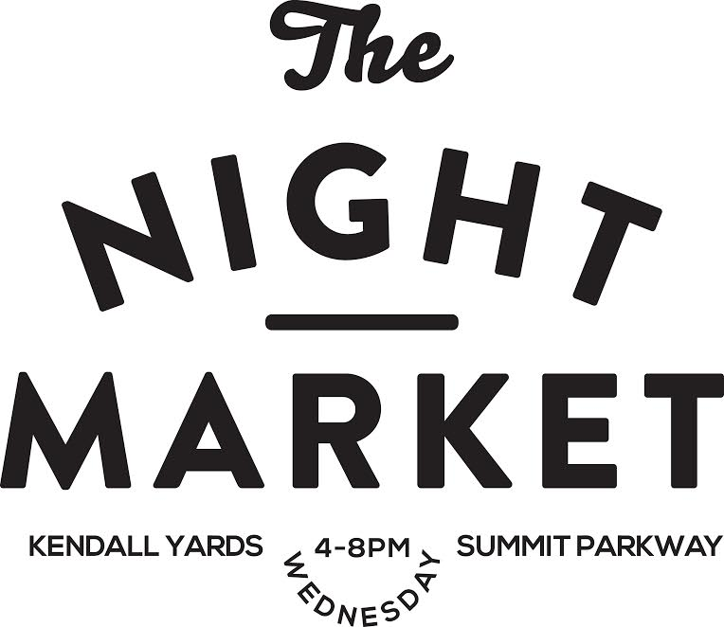

VENDOR HANDBOOK
2021

ABOUT US
The Kendall Yards Night Market (KYNM) is an independent farmers market, organized by the Kendall Yards community and Spokane Neighborhood Markets. Our market’s mission is to support small farms and build community. A vibrant marketing and event schedule attracts customers from all over the city. Kendall Yards enjoys high visibility in a convenient and beautiful location. A market has always been in the plans for the community. We have now developed the infrastructure to support the market and 2015 was our first year of operation. Our market has an emphasis on farmers and locally grown farm produce and includes processed foods, street food vendors, limited art/craft vendors and entertainment.

LOCATION
Our market is located on Summit Parkway between Cedar and Adams Alley in the Kendall Yards retail district. Ample vendor and customer parking is available on adjacent parking lots and streets.

SEASON
Wednesdays, 4:00 pm to 8:00 pm, from May 19 to September 22, 2021. The market will be open until 9pm on a number of Special Event Nights. (Severe weather conditions may necessitate the closure of the Market due to safety concerns. This closure will be at the Director’s discretion. Dates and hours may be subject to change. The Director may close the market at 7pm in early and late season, depending on available light.)

WHO CAN SELL WHAT
Products sold at the Market are generally limited to five categories, listed below as A though E. Each vendor’s application must detail exactly what products the vendor intends to sell. Vendor must be an active owner/operator of the business and may not be operating the business under a franchise agreement. Vendors may only sell products listed on their applications. If a vendor wishes to later add or discontinue a product, they must inform the Manager. Requests for adding new products to sell will be addressed on a case-by-case basis.
Any violation of these rules will result in the product being automatically removed from the vendor’s tables and possible revocation of the vendor’s Permit to Sell. Interpretation of this rule is at the Director’s discretion.
A. FRESH FARM PRODUCTS: Fresh fruits and vegetables, herbs, nuts, honey, dairy products, eggs, poultry, mushrooms, meats, fish and shellfish. Also included are fresh cut flowers, nursery stock, and plants, and foraged items such as wild herbs or mushrooms. All fresh farm products must be grown or produced in Washington, Idaho, or Oregon and grown, produced, or foraged by the farmer/vendor selling them.
Only farmers, ranchers, fishers, apiaries, nurseries, and foragers may sell fresh farm products. Farmers and nursery operators must propagate all plants and flowers from seed, cuttings, bulbs or plant division. Honey vendors must be the owner-operators of bee hives from which they sell hone. Vendors must be active owners/operators of the farming operation and may not be operating the business under a franchise agreement. All dairy, eggs, poultry, honey, meats, fish, shellfish must have the proper permits and licenses as required by the WSDA and Spokane County Health District.
B. VALUE-ADDED FARM FOODS: Includes preserved foods, jams, jellies, juices, cider, wine, distilled spirits, syrups, salsas, smoked or canned meats or fish, dried fruit, flours, salad dressings, and limited on- site processed farm food such as roasted peppers & roasted peanuts. Wines allowable for sale at the Market must use grapes and fruit grown in the five wine appellations of Washington, Idaho or Oregon.
All value-added farm foods must be made from raw products and ingredients, a majority of which are grown and produced by the farmer vendor. The vendor must also be the creator of the value-added farm foods being sold (i.e. personally cooking, canning, baking, or preserving the product itself or supervising their own raw ingredients used in accordance with their own recipes in a permitted facility). All processed value- added farm foods must carry product liability insurance.
C. DRIED FLOWERS, CRAFTED FARM PRODUCTS: Bouquets, wreaths, roping, vine and woven wood baskets, arrangements and displays of fresh and dried flowers, vegetables, vines and gourds. Beeswax candles are allowed by honey producers only. Other non-edible crafted farm products will be considered on a case-by-case basis.
All crafted farm products must be made from raw products and ingredients, a majority of which are grown and produced by the farmer vendor. The vendor must also be the creator of the crafted farm products being sold
D. PROCESSED FOODS: Preserved foods, jams, jellies, juices, cider, wine, distilled spirits, syrups, salsas, smoked or canned meats or fish, dried fruit, salad dressings, breads, pastries, baked goods, pasta, granola, and related take-home foods. Wines allowable for sale at the Market must use grapes and fruit grown in the wine appellations of Washington, Idaho or Oregon.
Processed foods must be produced by the vendor from raw ingredients. Vendors in this category are those who have cooked, baked or otherwise treated the product they sell, but have not raised the ingredients themselves.
E. PREPARED FOODS: Freshly-made foods available for sale and immediate consumption onsite, such as pizza, sandwiches, tamales, and crepes.
F. ART AND CRAFTS: The Kendall Yards Night Market may allow, on a limited, case-by-case basis, vendors selling high quality art and craft items that promote our mission of supporting local artisan. Priority is given to local artists and craft persons.

HOW PARTICIPATION IS DETERMINED
The Market grants Permits to sell based on the Market's need to balance available produce with a well- rounded product mix. The Market strives to meet the needs of participating farmers and our goal of creating a vibrant and successful market.
A. MARKET STAFF: The Director’s job is to implement Market policies. This includes overseeing vendor participation and booth assignments, set-up, collection of fees, providing information on Market policies, and assuring vendor compliance. The Director is also responsible for public concerns and vendor concerns. The Director has complete authority to interpret and implement policy on the Market site, as necessary, and to make all decisions regarding Market participation, stall assignments and other Market operations.
B. PARTICIPATION is determined by the Market, whose job is to provide a healthy, viable mix of new and current vendors, including experienced vendors with a proven record of high sales and consistent quality/variety. The goal is to create an economically successful and sustainable Farmers Market, while also providing increasing opportunities for new vendors to sell their products directly to customers.
Decisions are based on available space in the Market, the need for specific products, vendor’s fit with Market mission and demographic, and vendor’s performance history. Criteria for evaluating vendor performance will include: ability to follow market policies and Director’s directions (e.g., communication, punctuality, clean-up, weights, signage, 48 hrs. advance notification when canceling, etc.), product quality, visual display, sales history, and record of no outstanding balances.
The goal of the Night market is to create a Market vendor mix with at least 50% farmers. The Night Market is also committed to supporting and helping incubate smaller start-up businesses and artisans in vendor categories D, E and F, when possible. Priority is given to returning vendors.

HOW STALL ASSIGNMENTS ARE MADE
STALL ASSIGNMENTS are made by the Market based on the following criteria: (1) available space in the Market, (2) the need for a specific product and the vendor’s ability to provide it, and (3) the number of spaces the vendor requires, and (4) vendor history and sales performance.
Participation in the Market is not a guarantee of a particular stall location. The Director will make every attempt to keep stall space assignments consistent throughout the season. However, stall assignments will change over the course of the season in order to maximize shopper experience, make the best use of Market space, and provide a good mix of products.

2021 MARKET PARTICIPATION FEES
APPLICATION FEE: None. There will be no application fee charged to the vendors for our 2021 season due to COVID-19.
DAILY STALL FEE Stall size
- 10 X 10 space
- 10 X 20 space
There will be no stall fee charged to the vendors for our 2021 season.

MARKET RULES AND POLICIES

Kendall Yards Night Market (KYNM) has established rules and policies ensure that the market is a fair, safe and positive experience for all vendors, customers and staff.
1. SAFETY: All instructions given by any of the market staff require your cooperation and immediate compliance. The sidewalks and fire lanes must be kept clear at all times. Vendor vehicles, tables and overhead shades must be maintained and used in a safe manner. Table legs must be firmly locked into place. Tables must have smooth edges and remain stable when loaded with produce. Tent poles, canopy legs, boxes, umbrella stands must not obstruct foot traffic flow; care must be taken when setting up or taking down displays. Cords must be taped down.
2. QUALITY: Products must always be of the highest quality. Produce must be fresh and free of residue that cannot be removed by normal washing.
3. LICENSES/ PERMITS: Vendors must have a copy of every license and/or permit legally required by the WSDA/USDA, state of Washington, Spokane County and the City of Spokane etc. in order to conduct business.
4. GUIDELINES/ REGULATIONS: Food vendors must comply with all guidelines of the USDA, FDA, WSDA, DNR, DOH, other State of Washington authorities, if required, City of Spokane, the Public Health Spokane & Spokane County, and any other legal authority with jurisdiction over their products. Processed foods require labels that comply with all state and local labeling codes.
5. SAMPLING: Requires a hand wash set-up that will be approved according to specifications of the Public Health guidelines.
6. SETUP/ TAKE DOWN TIMES: Vendors are not allowed on the site before 2:00 pm. All vendors must vacate the site by 9:00 pm. The Market site is not staffed outside of these hours.
7. LOADING/ UNLOADING: Summit Parkway is closed starting at 12pm on market days, vendors are to drive through East to West. Please unload quickly and then park outside of the market area (Unless authorized parking is provided by Market Manager in advance). Vendor vehicles must be off-site no later than 30 minutes before the Market opens.
8. HONESTY: All vendors are expected to respond to a customer’s questions truthfully. A product may be labeled “organic” and/or “transitional” only if a copy of the state certification is posted for viewing in your vending space. A vendor who is not certified organic may not have any posted item that has the word “organic” at the stall.
9. SIGNAGE: Signs are required and all displays should be clear and legible. The farm/ business’ name and all prices must be visible to all customers. Displays and signs must allow for clear visibility. Product displays should be placed appropriately to avoid the reach of dogs.
10. SET OUT DISTANCE FOR VENDOR DISPLAY: Displays and signs must allow clear visibility to adjoining booths. Display and selling techniques must not impair other vendors’ ability to sell, nor create a hazardous situation for customers. Our intention is to create a visually enticing Market for customers and to enable all vendors to maximize their selling space.
11. SELLING SPACE: Vendor stalls, selling space and vehicles must not extend beyond allotted boundaries of the stall space without prior approval of Director.
12. SCALES: Scales must be accurate, maintained according to state law and located so customers can see weights during the transactions.
13. CANOPIES: Sides for canopies should only be used for extreme weather protection as needed. Canopy walls tend to limit the line-of-sight of a large, robust and varied market. All canopies must have 25 lb. weights attached to each leg or you may be asked to take your canopy down.
14. NO SMOKING: Smoking is not allowed at the market site.
15. VENDOR TRASH: Pack it in and pack it out. Haul your trash, compost and recycling home with you. Vendors are responsible for keeping their space clean and attractive during the day and for leaving the space clean at the end of the day. A tarp, broom and garbage bags should be part of your equipment. The trash bins are for market visitors only.
16. MARKET HOURS: Selling times are restricted to the hours of each market. The only exception to this rule is for sales to other vendors, pre-orders and for sales to chefs. All vendors must stay until the end of each market. Please check the Special Events schedule as we will be open late on several market days.
17. PARKING & ELECTRICITY: Parking is available adjacent to the market. In some instances the vendor may be able to park a vehicle necessary for serving his stall in an area adjacent to the stall. These locates are very limited. Electricity is available at several stall locations.
18. ICE/WATER DUMPING: No contaminated ice/water dumping is allowed in the public areas. Water with soap/bleach must be disposed of in a sink/toilet plumbed to the city sewer or taken home. Check with the Market Manager for a location to dump clean water and ice.
19. STALL SPACE CLEANUP: Vendors are required to maintain their individual selling space in a clean, safe and sanitary manner, including protecting the pavement from drips from any part of the vendor’s vehicle. Each vendor is responsible for complete cleanup of their space at the close of the Market. This includes taking with you any trash or garbage that is generated in or around your stall and sweeping up any product debris left on the ground. All prepared food vendors must provide their customers with a place to dispose their waste. Farmers are not permitted to dispose of produce waste, overripe or leftover produce or boxes in any on-site garbage cans or dumpsters. Market trashcans and dumpsters are not available for vendor use. Vendors must bring their own brooms, dustpans and waste bags. Fees may be charged for any garbage left behind.
20. OUT SICK: If you are ill, you must call out sick. Call the market telephone to cancel as soon as you can. Sneezing, coughing, spitting and other unsanitary behaviors can be detrimental to business.
21. NO SHOW: Each vendor is responsible for attending the market when scheduled. 24 hour cancellation notice by email or telephone is required. There is a fee associated for no shows and your membership may be revoked if circumstances arise.
22. BOOTH AUDITS: The Night Market may conduct random booth audits at any given vendor’s stall during the Market season. These audits will be carried out by independent third party observers.
23. VALUABLES: Be vigilant and careful regarding your personal bags and especially with your cash box. Keep your cash box behind a barrier. The market is not responsible for lost or stolen goods. Perform standard examination of currency to reject anything that looks counterfeit.
24. CLOTHING: All participants are required to wear shoes and appropriate tops and bottoms during business hours. If the market staff finds your attire offensive, you will be asked to change.
25. COURTESY/CONDUCT: The Market is a community event where many diverse people are gathered to shop and sell. Vendors and their representatives are expected to conduct themselves in a respectful, safe, courteous and harmonious manner with customers, Market staff and with each other. Any language or behavior that jeopardizes the normal operations of the Market will be grounds for termination of the vendor’s Permit to Sell. There will be no discrimination according to race, color, creed, sex, religion, sexual orientation, age or nationality.
26. NO WEAPONS
27. PRODUCT DEMONSTRATIONS: Special product demonstrations may be allowed with preapproval by the market management. Failure to comply with any of these market policies can result in fines and/or expulsion from the market. As a business owner, you are expected to train any staff working at the market, and for educating your staff to adhere to these policies. All decisions made by the Market Manager regarding these rules and policies are final and binding.
28. MARKET CURRENCY: With the implementation of the EBT (Electronic Benefit Transfer)/Credit/Debit card program at the Kendall Yards Night Market all vendors selling items eligible for food stamp purchase must participate in the program. All other vendors are strongly urged to participate in order to avoid customer confusion. ALL vendors agree to abide by the rules of the USDA Food Stamp Program. My signature below confirms that I understand and will abide by the USDA Food Stamp Program Rules following this paragraph. I will be reimbursed by check for the tokens turned in for redemption. Management reserves the right at its sole discretion to make changes to this program in order to alleviate deficiencies or comply with Federal, State, County, City or Washington State Farmers Market Association rules.
29. REPORTING REQUIREMENTS: Vendors must report their daily gross revenue to Director at the end of each market, on the Sales Report Form provided, which they shall sign and verify as accurate. Vendors who fail to report accurate sales forfeit their right to sell at the Night Market. Gross revenue includes all cash sales as well as the value of pre-orders. All reports must be collected within 30 minutes of market closing time.
30. VIOLATIONS: Failure to comply with any of the rules will result in warnings and/or fines, and possible Termination of Vendor’s Permit to sell, at the Director’s discretion. The first violation will be a Verbal Warning, the second violation will result in a $25 fine, and the third violation will result in additional fines or dismissal from the market.
31. COVID-19: Please see attached COVID-19 current guidelines. As the global pandemic continues to change we will continue to follow the government recommendations, social distancing guidelines and are prepared to change the market in any ways needed to comply with the rules. Masks are required for all attending and working the market for the 2021 season.
If provided a Permit to Sell, your participation in the Night Market is voluntary, as is the Night Market's choice to have you participate. At any time either party may terminate this contract. The Night Market reserves the right to modify these Guidelines and Policies at its discretion. All vendors will be notified if any changes are made.
We encourage you to keep a copy of these Guidelines and Policies at your stall for easy reference by staff.
Thank you for following our rules. Working together we can ensure a wonderful season!

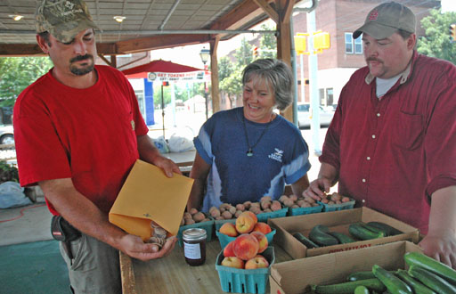

TYPES OF MARKET CURRENCY
MARKET TOKENS: At the Market info booth customers can buy tokens with EBT cards or credit cards. All vendors must accept tokens, KYNM will cash vendors out at the end of the day. If the tokens equal more than the amount charged the vendor needs to make cash change. Again KYNM will give you the full reimbursement for tokens in the form of a check. *All Night Market Tokens are exclusive to this market and vendors cannot accept non-Night Market tokens.
- $5 DEBIT TOKENS: These are the $5 Tokens customers receive when they swipe their debit card at the info booth. These are treated as cash at the market.

- $1 EBT TOKENS: Households CAN use SNAP benefits to buy all foods that intend for consumption at home including:

- Breads/cereals, dairy products, meat, fish, poultry, fruit and vegetables.
- Non-alcoholic beverages, snack foods, soft drinks, candy and ice.

Households CANNOT use SNAP benefits to purchase:
- Beer, wine, liquor, tobacco, or cigarettes
- Foods that are hot at the point of sale
- Foods to be eaten at the Farmers Market
- Vitamins or medicines
- Pet foods
- Nonfood items such as tissues, soaps, cosmetics or other household goods

You may NOT set a minimum purchase requirement or charge sales tax and NO cash may be given as change for EBT (Food Stamp) Tokens. Only red $1.00 EBT tokens can be given as change for blue $10.00 EBT (food stamp) tokens. Change can be given for green $5 Credit/Debit Tokens.

FRESH BUCKS:
What are they? Fresh Bucks provides Supplemental Nutrition Assistance Program (SNAP, formerly known as “food stamps”) shoppers with extra buying power at our Spokane Farmers markets. The program matches SNAP dollar-for-dollar up to $10 per cardholder per market per day.
What markets use them? How do I cash them in? KYNM takes Fresh Bucks, vendors can turn them in at the end of the day towards their total reimbursement check.
What can customers buy with Fresh Bucks? Fresh Bucks are for fruit, herbs, mushrooms, vegetables and vegetable starts. Each year the color changes on the Fresh Bucks coupon, 2017 is green.
KERNEL CASH:
Kids Eating Right Nutrition and Exercise for Life (KERNEL) introduces children to healthy living and eating habits through simple weekly activities at local farmers markets. In exchange for their time and participation, children receive a $2 voucher, aka, KERNEL cash, that they can use to purchase fresh produce or plant starts at the farmers market.
Allowing kids to purchase market produce with their KERNEL cash gives them experience participating in commerce and exchange, allows them to develop communication skills as they purchase food, and reinforces the idea of supporting local farmers and communities through participating as farmers market customers. The KERNEL program is in partnership with Catholic Charities Food for All and Spark West Central. Sponsorship of our 2017 program will be provided by Greenstone Homes.

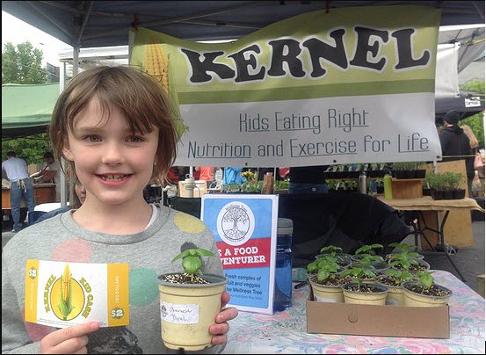

WIC & SENIOR FARMERS MARKET NUTRITION (FMNP) CHECKS:

What are FMNP? The WIC and Senior Farmers Market Nutrition Programs (FMNP) provide locally grown fresh fruits and vegetables for WIC participants and lower income seniors. The programs also strengthen local economies and communities by promoting Washington State agriculture.
The WIC Farmers Market Nutrition Program is part of the Special Supplemental Nutrition Program for Women, Infants and Children (WIC). The WIC Nutrition Program provides nutrition screening, health referrals, nutrition education, and nutritious foods to supplement diets for low income families.
The WIC Farmers Market Nutrition Program is designed to provide families participating in the Special Supplemental Nutrition Program for Women, Infants and Children (WIC) with locally grown fresh fruits and vegetables. Packets of $2 checks at a value of $20 are distributed to clients at participating WIC clinics across the state June through September. Checks are redeemable for fresh fruits and vegetables at approved farmers markets June through October.
In 2007, $25,047 worth of farm fresh produce was obtained by WIC families who used their coupons at the Spokane Farmers' Market. Statewide, $607,995 worth of fresh fruits and vegetables were distributed to WIC families at 81 participating farmers markets.
The Senior FMNP is part of the Senior Nutrition Program. The Senior Nutrition Program improves nutrition for low income adults over age 60. The program provides nutritious meals in a variety of group settings in the community and home delivered meals for seniors who are unable to leave their homes.
How does FMNP work?
Senior FMNP operates June through October. Eligible participants are age 60+ or are American Indian/Alaska Native and 55+ and have income below 185% of Federal Poverty Level ($1,575 per month for one in 2007) within funding limitations, eligible seniors are issued $40 worth of $4 checks. These checks are used to purchase local produce at authorized farmers markets or roadside stands June through October OR local produce purchased directly from farmers and delivered to home bound seniors or to meal sites and senior housing for pick up by eligible seniors.
How can you participate in FMNP?
Growers who wish to participate with FMNP must submit an application to the DOH and agree to a contract in order to accept WIC & Senior FMNP checks. The FMNP contract prohibits Growers from giving change for a FMNP check, please consider giving the customer extra produce if their transaction is not the full value of the check. FMNP Growers must have signs displayed visibly at each market and must have check stamped by the Market Manager weekly., please do not have check from Kendall Yards Night Market stamped at other markets.
Katherine D. Flores
Farmers Market Nutrition Program Lead
Washington State Department of Health
PO Box 47886 Olympia, WA 98504
Katherine.Flores@DOH.WA.GOV
Phone: (360) 236-3721 Fax: (360) 236-2345

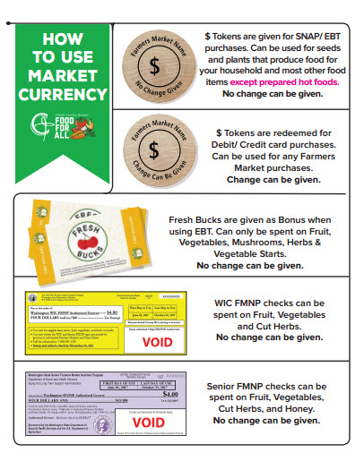WINE/ CIDER/ BREW SAMPLING
5
1
- Only beverages containing Washington-grown ingredients are allowed for sale.
- Samples are limited to a maximum of 2 oz. per customer, per day. A winery/brewery must hold a WSLCB Domestic Production License.
- Every server must have an appropriate serving permit.
- A UBI farmers market sales endorsement must be obtained prior to being allowed to sell at farmers markets.
- Advertising is allowed only within the canopy space.
- Customers must remain within the tasting space while sampling. You may not allow customers to leave with serving containers.
- You are required to refuse service to any customer that shows signs of intoxication.

Washington State Liquor and Cannabis Board
Licensing and Regulation - MIW
P.O. Box 43085
Olympia, WA 98504-3085
(360) 664-1721
FOOD HANDLING & PERMIT INFORMATION
A current UBI registration with endorsement may be required for particular produce.
Farmers are not required to have city of Spokane business license, or other permits, if they are not providing samples and if they are not selling taxable items.
KYNM requires that farms follow safe food handling guidelines needed for the type of produce being sold at market. All vendors that sell or provide samples of fresh produce, ready-to-eat prepared foods, or processed foods must comply with public health – City of Spokane food handling guidelines.
If you are not sure what is required of your product, it is every business's responsibility to be aware of, and to be in compliance with all permit and licensing requirements. Copies of all permits must be on site at all times. Contact the Department of Health if you have any questions. All vendors that provide samples must have a hand washing station in their canopy space. See market staff for directions regarding location of plumbed sanitary facilities. Bare hand contamination must be avoided at all times. Farmers’ produce boxes must be stacked off the ground. Melon samples are not allowed at any time by order of the State Board of Health. All food vendors who work with hot foods must wear clothing and shoes that offer protection from injury at all times.
Permit Information All regulations, policies & rules for farmers market vendors are available from the Public Health Environmental Health Department and/or the WSDA Food Safety Program. A WSDA processor license is required for anyone “handling or processing any food in any manner or preparation for sale for human consumption.” (RCW 69.07)
Washington State Department of Health
River View Corporate Center, Suite 1500
16201 East Indiana Avenue
Spokane Valley, WA 99216
Monday through Friday 8 am to 5 pm

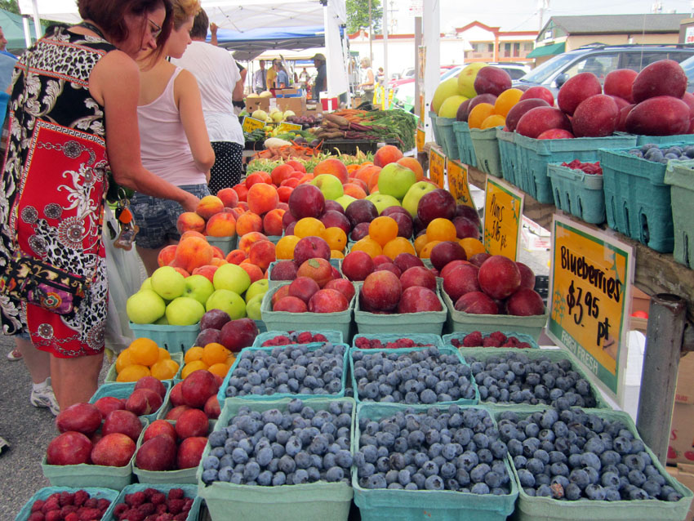

2021 Market Director: Sophie Solinsky
1335 W. Summit Parkway
Spokane, WA 99201
Email: market@kendallyards.com
Phone: (509) 724-8074

2021 MARKET SPONSORS
Greenstone Homes
Kendall Yards
Washington Trust Bank

COVID-19 UPDATE:
Farmers Markets are essential businesses. We provide a healthy open-air environment for grocery shopping with fewer people making contact with your food. We will be opening a small, rightly managed farmers market on Wednesday evenings from 5-8pm.

CHANGES IN MARKET ACTIVITIES:
- We will be closing earlier. The hours will be 5-8pm/this is subject to change
- A limited number of farms and prepared food vendors will be allowed to sell due to distancing booths and customer lines.
- Food consumption will only be permitted at tables

COVID-19 SAFETY PLAN:
- There will be a minimum of 6’ distance between each vendor booth.
- Vendors will be set up on the north side of Summit Parkway to allow more space for social distancing in lines.
- Marks on the road will demonstrate what a 6’ distance looks like.
- KYNM will provide hand sanitizing stations.
- Shoppers, market staff, volunteers, and vendors will be required to wash their hands.
- Vendors will minimize their displays and offer pre-bagged/ portioned food.
- No sampling of food or beverages.
- Signs will be posted at each vendor booth instructing customers NOT to touch food and to allow the vendor to handle food items with gloves on.
- All vendors will wear masks.
- Market staff and vendors will follow a regular cleaning schedule with all surfaces cleaned at least once per hour. The Market iPad and machine will be cleaned after each transaction.
- Vendors and staff will have one person designated for money handling and another for food handling.

THE SUCCESS OF OUR PLAN DEPENDS ON YOUR ACTIVE PARTICIPATION:
- Stay home if you are sick.
- Wash or sanitize your hands before entering the market.
- are unable to attend and remain socially distanced when you drop food off.

